New Joy of Driving Animation Display – CGEA1.3

Functional Description

The New joy of Driving is a way to enhance the user’s driving experience by displaying animations associated with drive modes. These animations are tied with vehicle speed, acceleration and lateral movement.

THE HPCM module is responsible for all the filters and calibration required to drive the speed and acceleration based animations, whereas the cluster is simply responsible to ensure that the animation displayed is smooth (not jittery).

The vehicle speed and acceleration based animation data transmitted by HPCM via the VehVAnimation_Pc_Dsply and the VehAAnimation_Pc_Dsply signals, and the lateral movement data is transmitted by ABS_ESC via the VehLatComp_A_Actl signal.

Interfaces

Interface Context Diagram (I/O Block Diagram)
New Joy of Driving Animation Display Context Diagram

Inputs

IR-REQ-349292/A-INTERNAL:
  - Operational_Mode: Refer to section Operational Modes

MUX message on the HS_CAN Bus

SIG-REQ-349279/A-VehLatComp_A_Actl Signal

Signal Name | Size (bits) | Detail | Units | Res. | Offset | State Encoded | Min | Max
VehLatComp_A_Actl | 10 |  | m/s^2 | 0.035 | -17.9 |  | -17.9 (0x0) | 17.835 (0x3FD)
 |  | No data exists |  |  |  | 0x3FE
 |  | Faulty |  |  |  | 0x3FF

SIG-REQ-349278/A-ActvDrvMde_D2_Stat Signal

Signal Name | Size  (bits) | Detail | Units | Res. | Offset | State  Encoded | Min | Max
ActvDrvMde_D2_Stat | 4 |  | SED | 1 | 0 |  | 0 (0x0) | 31 (0x1F)
 |  | SelDrvMde01 |  |  |  | 0x0
 |  | SelDrvMde02 |  |  |  | 0x1
 |  | SelDrvMde03 |  |  |  | 0x2
 |  | SelDrvMde04 |  |  |  | 0x3
 |  | SelDrvMde05 |  |  |  | 0x4
 |  | SelDrvMde06 |  |  |  | 0x5
 |  | SelDrvMde07 |  |  |  | 0x6
 |  | SelDrvMde08 |  |  |  | 0x7
 |  | SelDrvMde09 |  |  |  | 0x8
 |  | SelDrvMde10 |  |  |  | 0x9
 |  | SelDrvMde11 |  |  |  | 0xA
 |  | SelDrvMde12 |  |  |  | 0xB
 |  | SelDrvMde13 |  |  |  | 0xC
 |  | SelDrvMde14 |  |  |  | 0xD
 |  | SelDrvMde15 |  |  |  | 0xE
 |  | SelDrvMde16 |  |  |  | 0xF
 |  | SelDrvMde17 |  |  |  | 0x10
 |  | SelDrvMde18 |  |  |  | 0x11
 |  | SelDrvMde19 |  |  |  | 0x12
 |  | SelDrvMde20 |  |  |  | 0x13
 |  | SelDrvMde21 |  |  |  | 0x14
 |  | SelDrvMde22 |  |  |  | 0x15
 |  | SelDrvMde23 |  |  |  | 0x16
 |  | SelDrvMde24 |  |  |  | 0x17
 |  | SelDrvMde25 |  |  |  | 0x18
 |  | SelDrvMde26 |  |  |  | 0x19
 |  | SelDrvMde27 |  |  |  | 0x1A
 |  | SelDrvMde28 |  |  |  | 0x1B
 |  | SelDrvMde29 |  |  |  | 0x1C
 |  | SelDrvMde30 |  |  |  | 0x1D
 |  | SelDrvMde31 |  |  |  | 0x1E
 |  | Not used |  |  |  | 0x1F

SIG-REQ-349280/A-VehVAnimation_Pc_Dsply Signal

Signal Name | Size (bits) | Detail | Units | Res. | Offset | State Encoded | Min | Max
VehVAnimation_Pc_Dsply | 7 |  | percent | 1 | 0 |  | 0 (0x0) | 127 (0x7F)

SIG-REQ-349281/B-VehAAnimation_Pc_Dsply Signal

Signal Name | Size (bits) | Detail | Units | Res. | Offset | State Encoded | Min | Max
VehAAnimation_Pc_Dsply | 7 |  | percent | 1 | 0 |  | 0 (0x0) | 127 (0x7F)

IR-REQ-349300/A-Outputs
- NJOD_Level_1_Animation_Display
- NJOD_Level_2_Animation_Display
- NJOD_Lateral_Animation_Display

Function/Performance

F-REQ-349296/A-Operational Modes

Mode | Differentiating Vehicle Conditions
Sleep Mode | New Joy of Driving Animation Display Inactive
Limiting Mode | New Joy of Driving Animation Display Inactive
Normal Mode | New Joy of Driving Animation Display Active / Inactive
Crank Mode | New Joy of Driving Animation Display Active / Inactive

Voltage Levels

Refer to Cluster Features table located in the Operational Modes and Voltage Range Strategies section in this SPSS.

Human-Machine Interface

Visual

Indicator Graphics / Display Format
Example graphics (Final graphics and animation to be provided by HMI group):
1st layer animation graphics (based on vehicle speed):
Unbridled Mode Whisper Mode
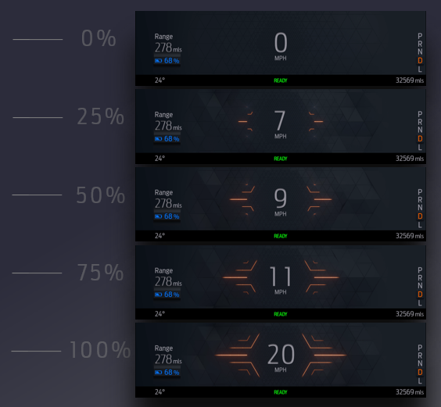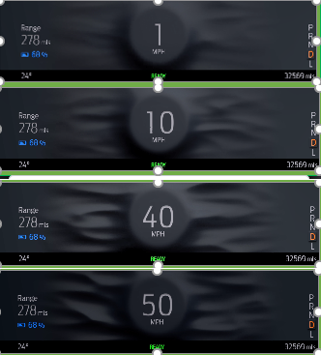

2nd layer animation graphics (to simulate a glow based on vehicle acceleration):
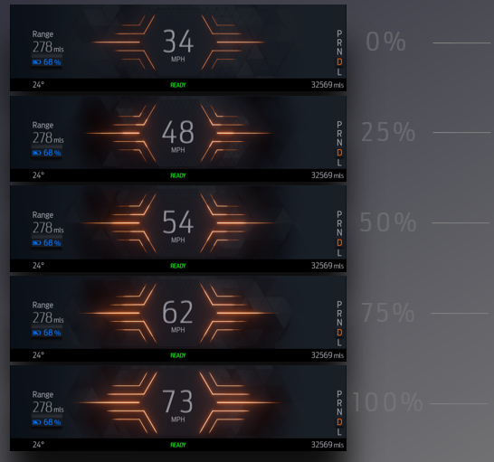

Right Turn example:
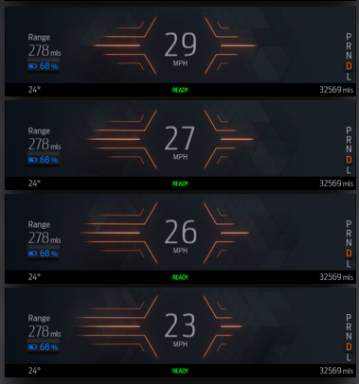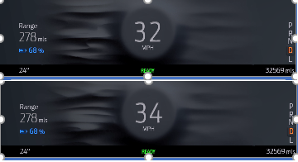

Left Turn example:
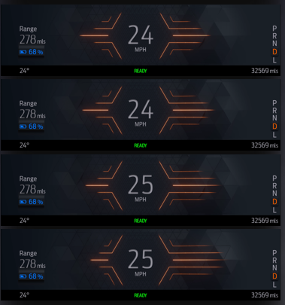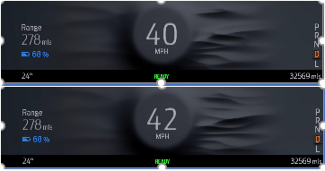

Indicator Color Coordinates

Indicator Characteristics

Audio

None

Switch Control Logic

Not applicable.

PFM-REQ-349295/A-System Accuracy

Within a 100msec of receiving a message that results in a change of state the cluster will update the display to the proper status. Shall indicate the data contained in input CAN signals.

Operation: Performance and Functional

Subsystem Algorithm Flowchart / State Diagram

F-REQ-349282/B-New Joy of Driving Animation Determination Algorithm

F-REQ-349283/B- NJOD Animation Display Process

F-REQ-349284/C- NJOD Lateral Animation Process

Operation Description (supports algorithm flowchart /state diagram)

F-REQ-349285/A-Input Signal filters
The HPCM shall filter and calibrate the VehVAnimation_Pc_Dsply and VehAAnimation_Pc_Dsply signal values before transmitting it to the cluster.

F-REQ-349286/A-Cluster response
Cluster shall simply drive the animation based on increasing and decreasing values of the input CAN signals. Supplier may choose a hysteresis value that ensures the animation is displayed smoothly.

F-REQ-349287/A-Cluster internal filter
The cluster shall implement a first order filter to ensure that the animation (growth and decay) is not jittery from one point to another. This filter may be product specific and be dependent on supplier design.

F-REQ-349288/A-Linear progression of animation
The progression between the animation and the magnitude of the CAN signals is linear.

F-REQ-349289/A-“Max” range/values
The “max” range/value of the animation graphics is product specific, hence defined by the HMI group. The cluster supplier shall break it down into desired steps to achieve the final animation.

F-REQ-349290/C-Lateral Movement Indication
A positive value in the VehLatComp_A_Actl signal indicates a left turn, hence the layer 2 animation shifts to the right of the center point. A negative value in the VehLatComp_A_Actl signal indicates a right turn, hence the layer 2 animation starts shifting to the left off the center point, as defined by HMI. If the lateral animation moves 10% to the right, it shall remove the same amount from the left side of the center to main symmetrical movement.

F-REQ-350377/B-Lateral Movement Filter in IPC
A direct form 1 filter shall be applied to the VehLatComp_A_Actl signal as follows to get a stable lateral movement animation displayed:

a[1] * y[n] = ( b[1] * x[n] ) + ( b[2] * x[n-1] ) + ( b[3] * x[n-2] ) - ( a[2] * y[n-1] ) - ( a[3] * y[n-2] )
Where,
a = denominator coefficients
b = numerator coefficients (as applicable)
x(n) = Unfiltered signal - VehLatComp_A_Actl
y(n) = filtered signal - VehLatComp_A_Actl
Once the values are generated after applying the filter, correction multiplier is then applied to get the final data.
The coefficient constants and multiplier are program dependent, hence, are provided directly by the program based on road tests and other factors.

The running filter is applied once 3 values of the valid unfiltered signal are received.
The filter may be applied at the same rate as the display update function.

F-REQ-350378/B-Minimum Lateral Animation Coverage
The IPC shall not collapse the first or second layer animation to less than a calibratable threshold on either side of the center point based on a change in lateral acceleration. There shall always be at least 5% percentage of the glow (determined by HMI) shown on the shorter side of the animation. This percent value (MIN_LAT_COVERAGE) may change based on vehicle level feature testing.

FS-REQ-349934/A-Function Safety Classification (EMC)

Class B

Memory Storage

NVM-REQ-350380/A-Memory Parameters

Parameter Name | Description | Value at Battery Connect | Value at Module Wake-up
VehVAnimation_Pc_Dsply Signal | CAN signal received from the HPCM indicating animation growth based on vehicle speed. | 0%  (0x0) | 0%  (0x0)
VehAAnimation_Pc_Dsply Signal | CAN signal received from the HPCM indicating animation growth based on vehicle acceleration. | 0%  (0x0) | 0%  (0x0)
VehLatComp_A_Actl  (HS-CAN) | Input latitudinal acceleration values sent from the ABS_ESC. | No data exists  (0x3FE) | No data exists  (0x3FE)
ActvDrvMde_D2_Stat | Input signal from ABS that determines current drive mode. | Faulty  (0x1F) | Do Not Init
NJOD_Layer_1_Animation_Display | Output layerl 1 animation display | Inactive | Inactive
NJOD_Layer_2_Animation_Display | Output layer 2 animation display | Inactive | Inactive
NJOD_Lateral_Animation_Display | Output lateral movement animation | Inactive | Inactive
Operational_Mode | 4 state indicator for cluster operational mode | Limited | Limited or Normal or Crank

NVM-REQ-350379/B-Data Constants Table

Parameter Name | Description | Unit | Res. | Min | Max | Initial Value
MIN_LAT_VALUE | Minimum absolute value of the input signal required to activate lateral animation. | m/sec² | 0.1 | 0.5 | 1.0 | 0.5
GROWTH_FACTOR | Multiplier used to calculate amount of lateral animation shifted to a given side. | # | 1 | 1 | 100 | 10
MIN_LAT_COVERAGE | Minimum lateral coverage displayed on the shorter side when longer side reaches max percent animation. | % | 1 | 1 | 20 | 5

Prove Out

No

Error Handling

SR-REQ-349297/A-Missing Message Strategy

The signals will be declared missing as per the Diagnostics section of this SPSS.

DTCs states and history will be determined as per the Diagnostics section of this SPSS.

SR-REQ-349298/A-Invalid Message Strategy

The VehLatComp_A_Actl signal data will be declared invalid as per the Diagnostics section of this SPSS.

DTCs states and history will be determined as per the Diagnostics section of this SPSS.

SR-REQ-349299/A-Unknown Message Strategy

The VehLatComp_A_Actl signal data will be declared unknown as per the Diagnostics section of this SPSS.

DTCs states and history will be determined as per the Diagnostics section of this SPSS.

Diagnostics

Self Test
None

Engineering Test Mode
Reference section “Dealer / Engineering Test Mode (ETM)”

Part II Performance
Reference Part II Diagnostic Specification

DTC-REQ-349294/A-Supported Diagnostic Trouble Codes (DTCs)

DTC | Description
C12100 | Lost Communication with ABS_ESC
C41581 | Unknown Data Received from ABS_ESC
C41500 | Invalid Data Received from ABS_ESC
C29300 | Lost Communication with HPCM

DID DExx
None

Reference Specification

- Func. Criticality EC-0048
- Mod. PWR-up / Reset EC-0049
- Low-High Vol. Perform. EC-0058
- Oper. Voltage Perf. IS-0052
- Oper. Voltage Func. IS-0053
- Symbol Usage 01-0238 / 01-0239
- Symbol Leg. 01-0240
- Placement - Parts Loc. 03-0001
- Harmony: Graphics / Font / Ill. 17-0040
- Ergo - Access. 17-0052
- Ergo - Operablility 17-0053
- Control & Display Loc. 17-0060
- Logical grouping Function and Usage 17-0062
- Assoc. of Controls with Disp. & elem. 17-0063
- Ill. Controls & Disp. 17-0074
- Id. Legibility 17-0081
- ID. Coding / Labeling 17-0083
- Logic of Op. 17-0120
- Op. Stereotypes 17-0121
- Interpretation 17-0122
- Feedback 17-0124

Revision History

SPSS Module Revision History

Revision Level | Name | Change Description | Date
1.0 | V. Patel | Initial release for New Joy of Driving Animation feature  DI CC approval: 3/14/2019  Feature Owner: Mohammad Kalash, Ford Studio  System Spec: Charbel Bouery  Spec tracking ID: 100227 | 4/16/2019
1.1 | V. Patel | There are no changes in feature functionality, this update provides clarification to supplier Q&A and fixes a few typos.  DI CC Approval: N/A  DI Spec Tracker: N/A  All updates are shown in red.  - SIG-REQ-349281: Fixed typo in signal name (copy/paste error)  - F-REQ-349283: Update flowchart to add a process block to clarify that lateral animation is inactive when input signals are missing or have value of 0%. Also updated process rate to 20 msec.  - F-REQ-349284: Defined the signal value of 0% for clarification. Also modified the equation to subtract the minimum lateral value during which animation is not active.  - F-REQ-349290: Corrected typos in describing lateral animation of left and right turns.  - F-REQ-350377: Added comment that numerator constants are used as applicable since CX727 does not show animation for forward accel and braking. (only lateral movement animation is shown)  - F-REQ-350378: Clarified that at least 5% of glow is always shown on the shorter side of the animation. This value is configurable.  - F-REQ-350379: Added MIN_LAT_COVERAGE to the constants table. | 8/8/2019
1.2 | V. Patel | The mode known as “Lightning” has now been renamed as “Unbridled”. “Serenity” is now called “Whisper”. And a new “Unbridled Extend” mode has been added, which has the same NJOD animations as the “Lightning” mode. This update reflects these changes. Changes are shown in blue.  - DI CC approval: 10/16/2019 (Offline)  - Change Requester: Jacob Landuyt (CX727 team)  - DI Spec Tracker: 454  - F-REQ-349282: Modified flowchart to rename the existing modes. Added Unbridled Extend (0xE) to follow the same animation as Unbridled (0x1) of the ActvDrvMde_D2_Stat signal.  - Also changed “Lightning” to “Unbrilded” and “Serenity” to “Whisper” to match final marketing approved mode names. | 10/17/2019
1.3 | V. Patel | This update fixes an issue in the interpretation of the VehLatComp_A_Actl signal, which is used to trigger the lateral animation. Currently, negative value indicated left turn and positive value indicated a right turn. This is incorrect and should be the reverse, as per the ABS group.  Changes are shown in green.  - DI CC approval: N/A  - Change Requester: N/A  - DI Spec tracker: N/A  - F-REQ-349284: Reversed the “Yes” and “No” paths coming out of the second decision diamond that checks for left or right turn animation.  - F-REQ-349290: Corrected the description, so that negative value indicates left turn and positive signal value indicates right turn. | 11/14/2019

